'Coordinate multiple patients' appointments' button

M2 : Coordinate_Patients_Icon

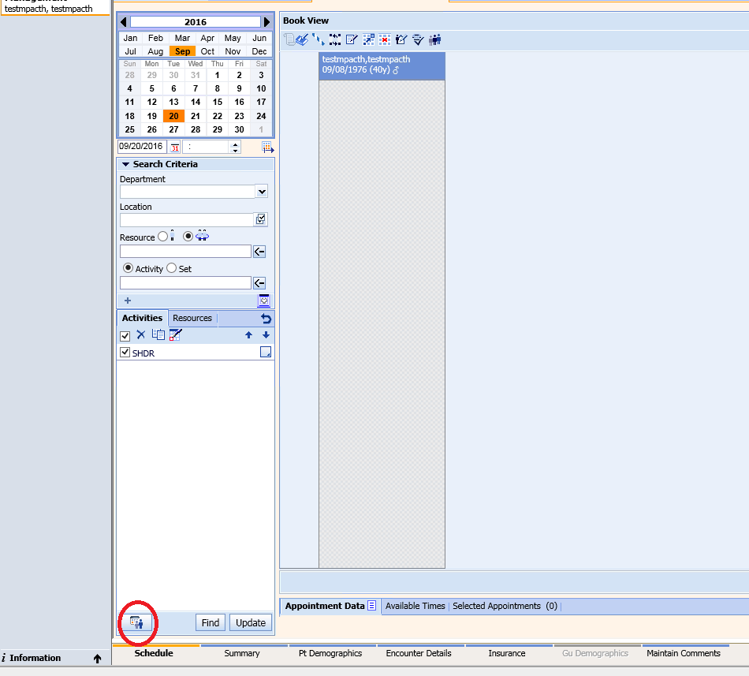

Appointment_Coordination_Dialog

M2 : Appointment_Coordination_Dialog

